Final Project Report

Sentiment Analysis on Yelp Reviews using LSTM and DistilBERT

Advanced Deep Learning
AIGC-5500
0NA

Rutu Patel – N01654478
Keyur Desai – N01666782
Elish Patel – N01652547

- Introduction:

In the digital era, online reviews have become a powerful medium for customers to voice their opinions about products and services. Platforms like Yelp are particularly influential in the food and hospitality industries, where customer experiences with restaurants and hotels are shared through detailed reviews. These reviews, ranging from brief comments to in-depth narratives, offer valuable insights into customer satisfaction and dissatisfaction. By analyzing the sentiment expressed in these reviews, businesses can gain a deeper understanding of their strengths and weaknesses. This project focuses on leveraging sentiment analysis techniques to classify Yelp reviews into positive, negative, or neutral categories, using a dataset composed of 6,000 customer reviews from the food and hospitality sectors. The dataset includes textual reviews and corresponding star ratings, which have been converted into sentiment labels for analysis.

- Dataset Description:

Dataset Features
The dataset contains the following key features:

- Business ID: A unique identifier assigned to each business. This feature helps in differentiating reviews belonging to different businesses.

- Text: The core component of the dataset, this feature contains the actual reviews written by customers. These textual reviews are rich in subjective content, providing detailed opinions about the food, service, ambiance, and overall experience at the business.

- Stars: A numerical rating ranging from 1 to 5 stars, provided by the reviewer. This star rating serves as a quantitative measure of the reviewer's overall satisfaction with the business.

Distribution of Reviews and Sentiment Labels

- The dataset comprises a substantial number of reviews, with each review contributing to the overall understanding of customer sentiment. To facilitate sentiment analysis, the star ratings have been converted into sentiment labels. The conversion is as follows:

- Positive Sentiment: Reviews with 4 or 5 stars are labeled as positive. These reviews typically reflect a high level of satisfaction with the business.

- Negative Sentiment: Reviews with 1 or 2 stars are labeled as negative. These reviews generally indicate dissatisfaction with the business.

- Neutral Sentiment: Reviews with 3 stars are labeled as neutral. These reviews suggest that the customer had an average or mixed experience, neither particularly positive nor negative.

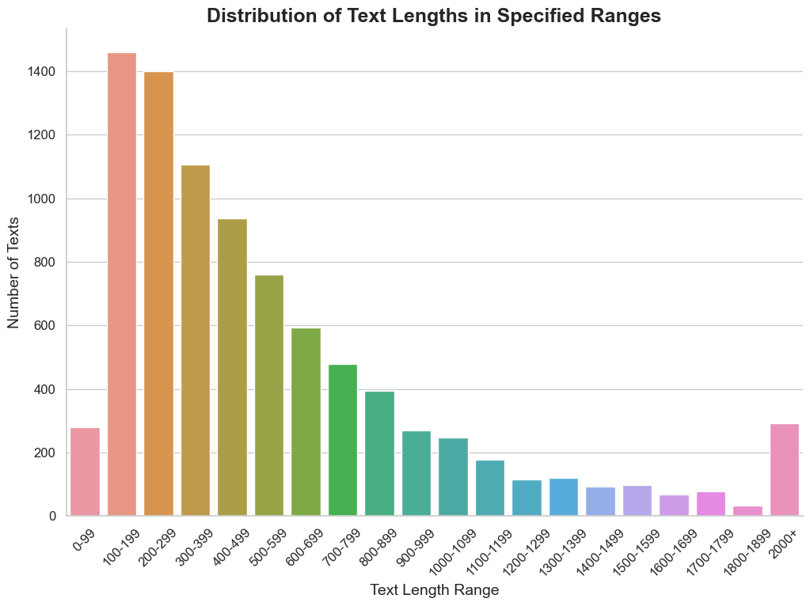

- Data Preprocessing:

- Text Cleaning: Before feeding the text data into the models, it is essential to perform several preprocessing steps to ensure that the input is clean and consistent.
The following methods were applied:

  - Lowercasing: All text was converted to lowercase to eliminate inconsistencies caused by case sensitivity.
  - Removal of Special Characters and Punctuation: Special characters, punctuation marks, and numbers were removed to reduce noise.
  - Lemmatization: Words were reduced to their base or root form to focus on essential meanings.

- Tokenization and Padding for LSTM Input: For the LSTM model, the preprocessed text data was further processed to convert it into a numerical format suitable for input into the model:

- Tokenization: The text was tokenized, meaning that each word was converted into a unique integer index. This process was done using a tokenizer that created a vocabulary based on the entire corpus of text.

- Padding: After tokenization, the sequences of words (now represented as sequences of integers) were padded to a consistent length. Padding is necessary because LSTM models require inputs of the same length. For instance, shorter reviews were padded with zeros, and longer reviews were truncated to match the predefined maximum length.

- LSTM Model:

The LSTM model, a type of Recurrent Neural Network (RNN), was tested with two configurations:

- Configuration 1:
Layers: 2
Dropout: 0.2
Optimizer: Adam
Epochs: 5
Accuracy: 63%

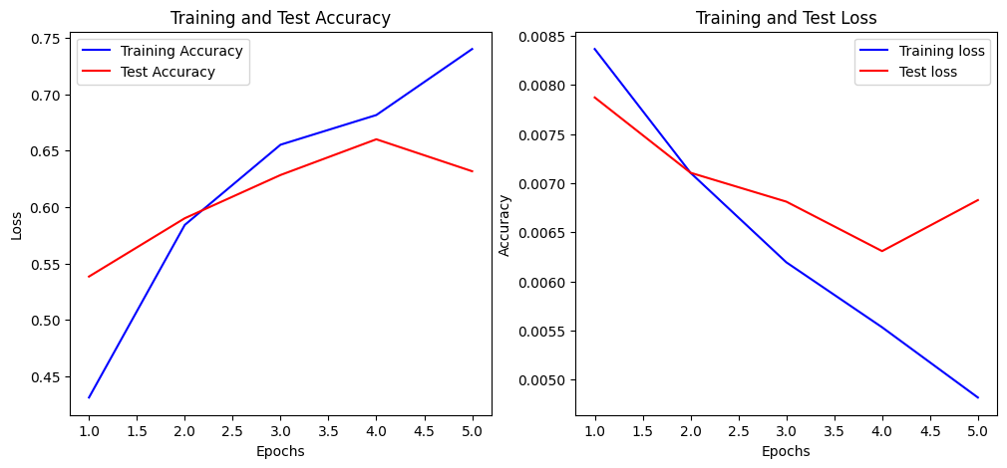

- Configuration 2:
Layers: 3
Dropout: 0.3
Optimizer: AdamW
Epochs: 3
Accuracy: 65%

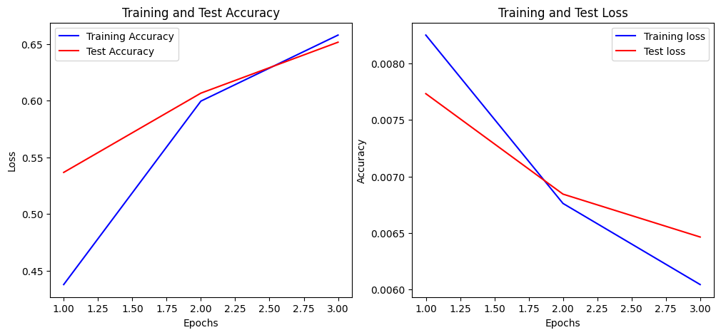
- The models were trained using preprocessed and padded sequences of text, with the final test results showing an accuracy of 63%, precision of 65%, recall of 65%, and F1 score of 65%.

- Training: Both LSTM configurations were trained using the preprocessed and padded sequences of text. The models learned to associate patterns in the sequences with the corresponding sentiment labels through backpropagation and gradient descent.

- DistilBERT Model:

- DistilBERT is a distilled version of the BERT model, designed to be lighter and faster while retaining much of BERT's performance. It is based on the Transformer architecture and excels in understanding the context of words in a sentence, making it highly effective for NLP tasks like sentiment analysis.
DistilBERT, a distilled version of the BERT model, was tested with two configurations:

- Configuration 1:
Train Batch Size: 64
Evaluation Batch Size: 64
Epochs: 3

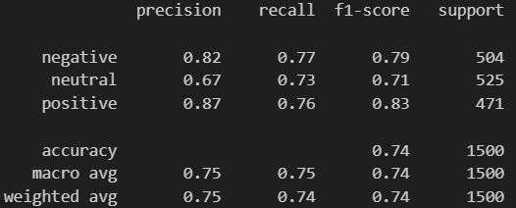

- Configuration 2:
Train Batch Size: 16
Evaluation Batch Size: 64
Learning Rate: 5e-5
Weight Decay: 0.01
Epochs: 3

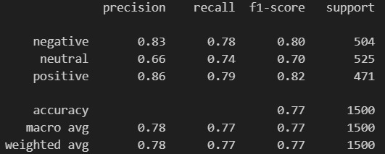

- The fine-tuned DistilBERT model achieved a test accuracy of 77%, precision of 78%, recall of 77%, and F1 score of 77%.

- Fine-Tuning: DistilBERT was fine-tuned on the Yelp reviews dataset. During fine-tuning, the pre-trained DistilBERT model adjusted its weights based on the specific task of sentiment classification. The final layer outputs the sentiment class probabilities for each review.

- Architecture: DistilBERT follows the Transformer architecture, which relies on self-attention mechanisms to process input text. The model consists of multiple layers of attention and feedforward networks, allowing it to capture deep contextual relationships between words. Unlike LSTM, which processes sequences sequentially, DistilBERT processes the entire sequence at once, making it more parallelizable and efficient.

- Challenges:
LSTM:
- Computational Resources: With a large dataset of 236,000 reviews, training LSTM models can be computationally intensive and require significant memory and processing power, potentially leading to longer training times.
- Overfitting: The extensive number of reviews increases the risk of overfitting, especially if the model complexity is high. Regularization techniques and dropout rates need careful tuning to mitigate this.
- Sequence Length Handling: LSTMs must handle varying sequence lengths, which can be challenging for very long or very short reviews, requiring effective padding and truncation strategies.
- Training Time: Training on a large dataset with multiple LSTM layers and epochs can result in lengthy training periods, necessitating efficient use of resources and potentially distributed training techniques.
DistilBERT:
- Memory and Speed: Despite being more efficient than BERT, DistilBERT can still be demanding on memory and computational resources, especially with large batch sizes and longer sequences.
- Fine-Tuning: With only 6,000 reviews, careful fine-tuning is essential to achieve optimal performance. Balancing learning rate, batch size, and weight decay is crucial for effective training.
- Data Size Limitations: The smaller dataset may limit the model's ability to generalize and capture complex sentiment patterns, making it necessary to use data augmentation or transfer learning techniques.
- Contextual Understanding: Although DistilBERT performs well, the model may struggle with capturing nuanced sentiment or context-specific expressions due to the smaller dataset size.
- Discussion:

Model Comparison:

LSTM vs. DistilBERT: The LSTM model handled the smaller dataset of 6,000 reviews adequately but encountered challenges with training time and overfitting. Despite the improvements made with different configurations, LSTM struggled to generalize as effectively as DistilBERT. DistilBERT, leveraging its advanced contextual understanding and efficient Transformer-based architecture, significantly outperformed LSTM in terms of accuracy and generalization, achieving a test accuracy of 77%, compared to LSTM's 63%.

Moreover, considering the architecture of DistilBERT, it is likely that if DistilBERT were provided with a larger dataset, such as the 236,000 reviews used initially for LSTM, its performance could potentially surpass LSTM by an even wider margin. DistilBERT's ability to process and understand context at a deeper level makes it better suited for large-scale sentiment analysis tasks. Therefore, while LSTM provided useful insights for the current dataset size, DistilBERT demonstrates a higher potential for scalability and accuracy, suggesting that with more data, it could achieve even greater accuracy and more reliable sentiment classification.

- Conclusion:

In this project, sentiment analysis was performed using both LSTM and DistilBERT models on a 6,000-review Yelp dataset.

- DistilBERT: Given its advanced architecture and efficient processing, DistilBERT outperformed LSTM with a test accuracy of 77%. Had a larger dataset been available, DistilBERT would likely have shown even more significant performance improvements.
- LSTM: While LSTM models showed reasonable performance, particularly with the larger configuration, they were less effective compared to DistilBERT on this smaller dataset. The 3-layer LSTM achieved a modest accuracy of 65%, highlighting its limitations with smaller data sizes.

Overall, DistilBERT demonstrates superior potential for sentiment analysis tasks, especially with sufficient data. Future work should focus on exploring the full capabilities of DistilBERT with larger datasets and consider integrating the strengths of both models for even better performance.

- References:
YelpDataset.(2022,March17).Kaggle. https://www.kaggle.com/datasets/yelp-dataset/yelp-dataset/data
Can, A. E. (n.d.-a). A comparison of LSTM and Bert for small corpus. https://arxiv.org/pdf/2009.05451

